|  |
| --- |
| Nice Netcat *15pts general skills* |
| Description:  There is a nice program that you can talk to by using this command in a shell: $ nc mercury.picoctf.net 22902, but it doesn't speak English... |

1. Type terminal command *nc mercury.picoctf.net 22902*
   1. Must have netcat installed
   2. Output is decimal numbers

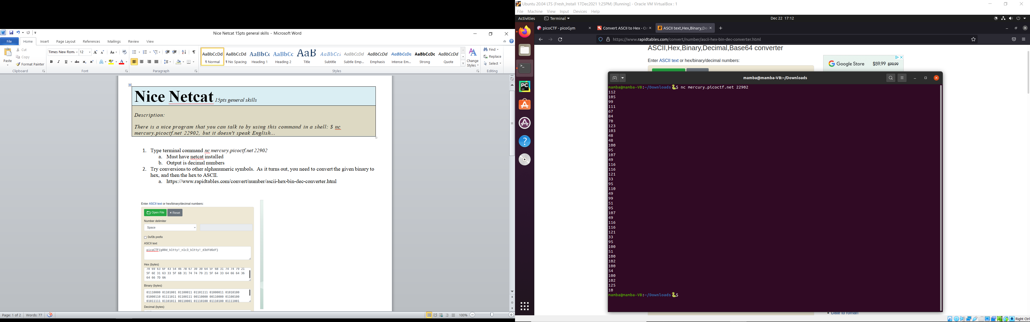

1. Try conversions to other alphanumeric symbols. As it turns out, you need to convert the given binary to hex, and then the hex to ASCII.
   1. https://www.rapidtables.com/convert/number/ascii-hex-bin-dec-converter.html

